Student’s name | …………………………………………………….…… | Grade | 1
Subject | Computer | Week No. | 4
Lesson Title | My Desktop | Unit
Worksheet No. ( 4 )

Question A: write the correct name of each part

Empty Recycle Bin | PC | Full Recycle Bin
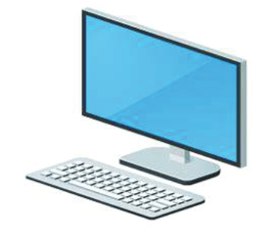


Good Luck

